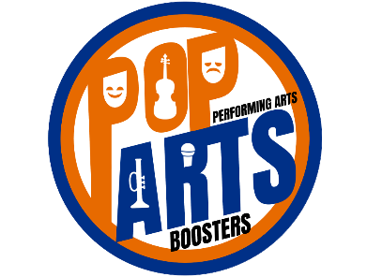
October 10-17, 2020

Orange Performing arts week of giving

Performing Arts Fundraiser
Once a year the Performing Arts students of Orange High School would go door-to-door throughout our community asking for tax-deductible donations. With the recent COVID-19 pandemic, it is not possible to do this event in person this year.
The generosity of our community helps fund our band, choir, orchestra, and theatre programs – and this year we need it more than ever! We ask that you continue the joyous spirit of giving by donating online or mailing your donation in.
To donate online, scan the QR code below or go to: http://www.popartsolsd.com/donate
Mail your donation to:
Orange High School
Attention: PopArts
2840 E. Orange Road
Lewis Center, OH 43035
Make Checks Payable to PopArts
We are hosting a drive-thru kick-off event at the Orange High School Bus Loop on Saturday, October 10, 2020 between 10:00 AM and 1:00 PM where you can drop off your donation to our performing arts students!
You may also pre-order Krispy Kreme Doughnuts or cupcakes from The Creamy Cravings and pick them up between 10:00 AM and 1:00 PM on October 10th as well. The Jazz Band and Marching Pioneer Drumline will be performing!
Order form for Krispy Kreme Doughnuts: https://forms.gle/id1LCpfNGhuUu74Q7
Order form for The Creamy Cravings Cupcakes: https://forms.gle/8dgtWTSMsAt14Qor8

